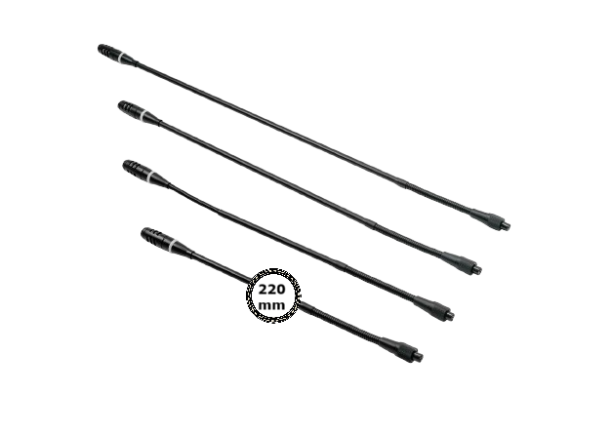

**DCS-M220**

Pluggable Gooseneck Microphone 220M

**FEATURE**

* Precise directional microphone head with Mini design.
* Two color LED ring indicator.
* Anti-wind microphone foam cover.
* Strong audio collection ability to work with different length of microphone.

|  |
| --- |
|  |
|  |

**FUNCTIONS**

* Two-color LED indicator on microphone, red for speaking, green means need acceptance from chairman to speak.
* Screw lock socket to connect removable microphone.

**ITEM MODEL FOR ORDER**

DCS-M220..................220mm Microphone, with anti-wind foam cover

DCS-M410..................410mm Microphone, with anti-wind foam cover

DCS-M485..................485mm Microphone, with anti-wind foam cover

DCS-M600..................600mm Microphone, with anti-wind foam cover

**TECHNICAL PARAMETERS**

|  |  |  |  |  |  |
| --- | --- | --- | --- | --- | --- |
| ITEM | DCS-M600 | DCS-M485 | DCS-M410 | | DCS-M220 |
| Directivity | Cardioid | | | | |
| Sensitivity | -46dBV/Pa | | | | |
| Frequency response | 30Hz~20KHz | | | | |
| Equivalent noise | 20dBA (SPL) | | | | |
| The maximum sound pressure | 125dB at 1KHz 1% T.H.D | | | | |
| Weight | 80g | 80g | 60g | 60g | |
| Length | 600mm | 485mm | 410mm | 220mm | |
| Color | black | | | | |

**About DAEWOO**

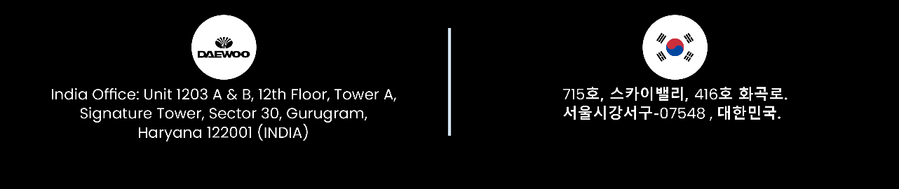 Our mission is to design and manufacture the most advanced and comprehensive audiovisual products for our clients. We strive to deliver the best performance-to-price ratio, ensuring satisfaction from the very first use. We believe that a combination of innovative design and cutting-edge technology adds value to our partners and end users. We listen to your needs and deliver solutions that fulfill them.